9-DAY SOUTHERN VIETNAM TOUR
Routing: Ho Chi Minh city – Cu Chi tunnels – Phu Quoc Islands
Tour Style: Nature, Culture & Relaxation Tour
Tour Start: in Ho Chi Minh city / Tour End: in Ho Chi Minh
Trip duration: 9 Days - 8 Nights

Day | Trip Summary | Meals
1 | HO CHI MINH CITY ARRIVAL – AIRPORT PICK UP | None
2 | HO CHI MINH HALF- DAY CITY TOUR – CU CHI TUNNELS | B/L
3 | EXPLORE THE MEKONG DELTA – OVERNIGHT IN CAN THO | B/L
4 | FLOATING MARKETING – BACK TO HO CHI MINH | B/L
5 | HO CHI MINH CITY – FLIGHT TO PHU QUOC ISLANDS | B
6 | PHU QUOC ISLANDS AT YOUR LEISURE | B
7 | PHU QUOC ISLANDS AT YOUR LEISURE | B
8 | PHU QUOC ISLANDS – FLIGHT BACK TO HO CHI MINH | B
9 | HO CHI MINH – DEPARTURE | B

TRIP DETAILS
DAY 1: HO CHI MINH CITY ARRIVAL- AIRPORT PICK UP [MEALS: NONE]
Welcome to Ho Chi Minh City – the biggest and most dynamic city in Vietnam! Upon your arrival at Tan Son Nhat International Airport, our friendly driver/guide will be waiting to greet you with a warm welcome sign. You’ll enjoy a comfortable transfer to your hotel in the city center.
On arrival at the hotel, you will proceed with check-in. Take this time to relax and settle in after your journey, or explore the nearby streets to start soaking up the vibrant energy of Saigon- Ho Chi Minh City.
Overnight in Ho Chi Minh City.
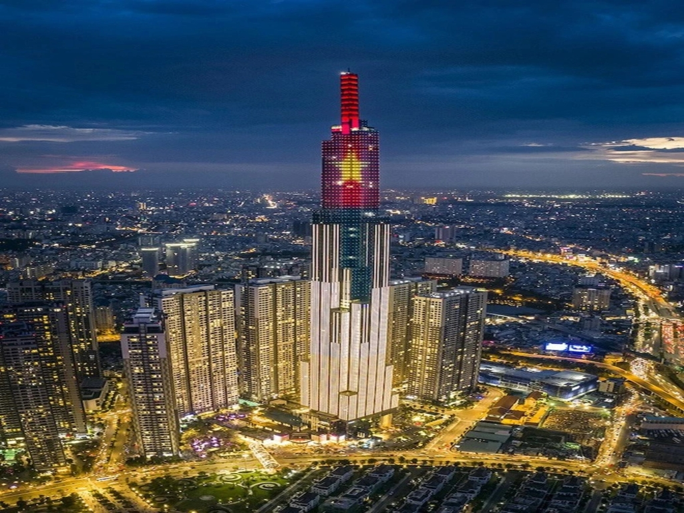

DAY 2: HO CHI MINH CITY HALF- DAY CITY TOUR- CU CHI TUNNELS [MEALS: B/L]
Having breakfast at hotel.
After that you will take the morning trip to visit Independence Palace, also known at the Reunification
palace, was built on the sight of the former Norodom palace. The Independence palace is a widely known landmark of Ho Chi Minh City and was designed by the architect Ngo Viet Thu. Continue seeing the beautiful structures from the French Colonial times such as the Notre Dame Cathedral, the historic Central Post Office. Followed by the remarkable site of the War Remnants Museum the museum has a vast display of the both the Indochina wars.
Have lunch at local restaurant.
Depart for Cu Chi tunnel, the trip will take approximately one and a half hours bus driving. Upon arrival, before exploring the tunnels, you will have some short introduction followed by introductory video about how the tunnels were constructed and how the people survived in the harsh conditions of the war time. Then, spend your time to explore the remaining area and tunnel systems which included the special constructed living areas with kitchens, bedrooms side by side with other martial facilities like storage, weapons factories, field hospitals, and command centers helping whoever lives inside the tunnels meet their basic needs. Besides, there are also many hidden trap doors and dangerous traps within the maze-like tunnels for security purpose during the war. Afterward, special tea and cassava (guerilla’s food during the war) will be served.
Break time for relax or time for those who want to try the real shooting gun (bullets you pat by yourself).
Back to hotel in Ho Chi Minh city.
Overnight in Ho Chi Minh city.
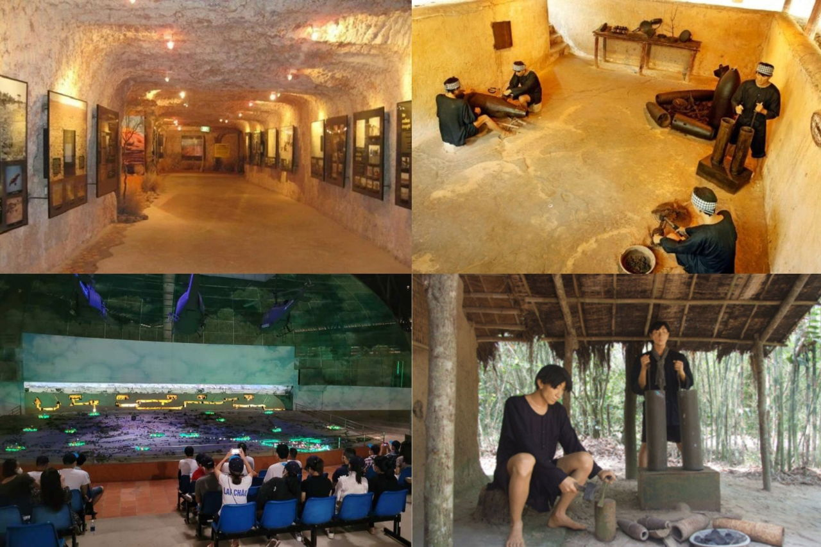

DAY 3: EXPLORE MEKONG DELTA TOUR [MEALS: B/L]
Having breakfast at hotel.
Heading out of town, we travel by roads to the Mekong Delta. This plain region boasts the largest rice bowl of Vietnam. On the way, we will visit Vinh Trang pagoda, the biggest pagoda in the Mekong delta. Upon arrival in My Tho, we board a boat navigating around the intricate small canals, which is a great way to observe the local lifestyle close-up and catch a view dotted by many islands. The exciting river trip will pass by the lush green vegetation towards the famous Unicorn Island where we have a chance to stroll around an orchard, taste many seasonal fruits, see farmers at work and Vietnamese folk music performed by the local people. We navigate some narrower canals using small rowing boats to Ben Tre Province for an interesting visit to some local industries. The extra enjoyment is a lunch at one of the famous local eating spots. After lunch, enjoy your time relaxing, walking around the village, or perhaps going for a short bike ride. Proceed to Can Tho City and overnight in Can Tho.
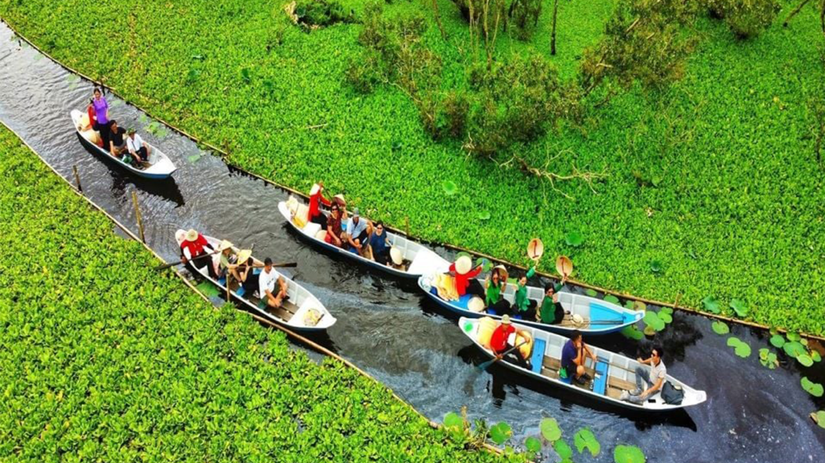

DAY 4: FLOATING MARKET – BACK TO HO CHI MINH [MEALS: B/L]
Having breakfast at hotel.
Have breakfast at the hotel. Take a leisure boat trip to explore the picturesque tributaries of the Lower Mekong River (Bassac River) then visit to Cai Rang floating market which is the liveliest one in the whole of region. Take in the beautiful scenery and the daily activities of the locals who live along the Mekong canals. Enjoy fresh fruits on boat and walking trip to visit local noodle factory. Have lunch and return to Ho Chi Minh City.
Overnight in Ho Chi Minh.

DAY 5: HO CHI MINH CITY- FLIGHT TO PHU QUOC [MEALS: B]
Having break at hotel.
Then you are free and relaxing before meeting our driver to get private transfer to Tan Son Nhat Airport.
Flight to Phu Quoc Island . This flight usually takes about 1 hour to 1 hour and 15 minutes. Upon arrival in Phu Quoc, you will be transferred to your accommodation to check in and drop off your luggage.
Then you are free to explore Phu Quoc
Overnight in Phu Quoc

DAY 6: PHU QUOC – FREE DAY [MEALS: B]
Having breakfast at hotel.
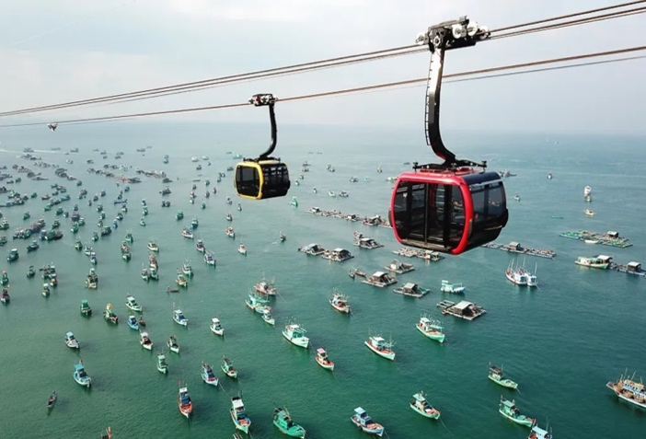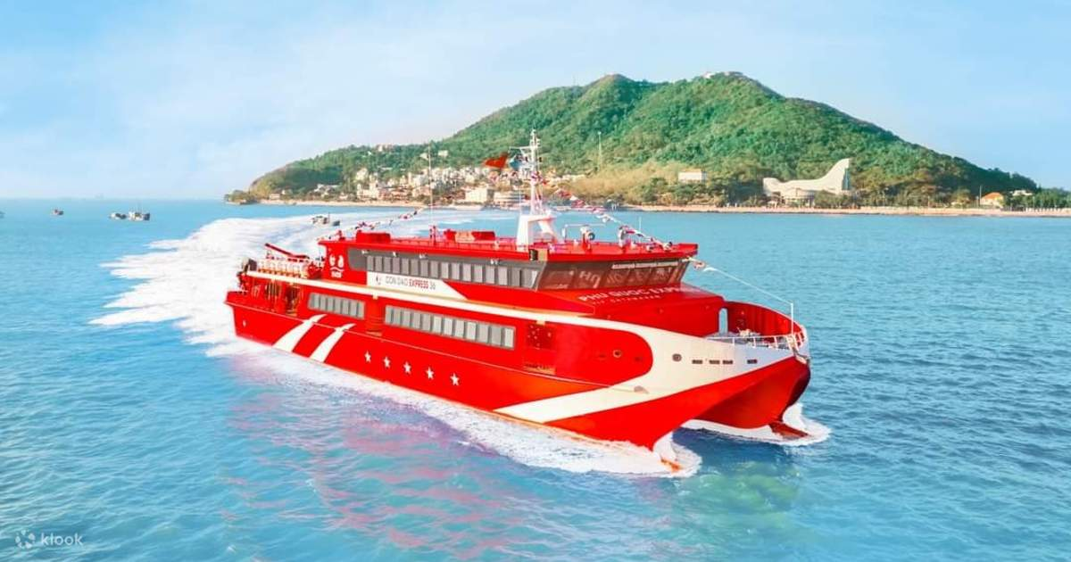

OPTIONAL TOUR: ISLANDS SPEED BOAT – CABLE CAR TO HON THOM (L)
Then Embark on an Island Speed Boat Tour from An Thoi port. This typically includes snorkeling or swimming at beautiful islands like Hon Roi, Hon Mong Tay, and Hon May Rut, known for their clear waters and vibrant coral reefs. After the island hopping, you will head to the Sun World Hon Thom Cable Car station. Board the world's longest sea-crossing Cable Car to Hon Thom Island. The ride offers breathtaking aerial views of the archipelago. On Hon Thom, you'll have access to Sun World Hon Thom Nature Park, which includes Aquatopia Water Park and various beach activities.
Late Afternoon Return via cable car to the mainland and proceed to Sunset Town (also known as Mediterranean Town). This beautifully designed area features European-inspired architecture, charming streets, and the iconic Kiss Bridge. As dusk settles, find a good spot to witness the spectacular sunset.
Then we go back to hotel for relaxing !
Overnight in Phu Quoc

Optional activity: The evening culminates with the grand "Kiss of the Sea" show, a world-class multimedia performance with water, fire, lasers, international artists, and a nightly Fireworks Show. This is a ticketed event.

DAY 7: PHU QUOC AT YOUR LEISURE [MEALS: B]
Having breakfast, then you are to discover Phu Quoc Island
OPTIONAL TOUR 1: VinWonders & Vinpearl Safari Immersion [NO GUIDE] [Meal: NONE]
Dedicate your entire day to the Vinpearl complex in the north of Phu Quoc.
Start with VinWonders Phu Quoc, Vietnam's largest theme park. It offers six themed zones with a wide array of rides, shows, and attractions suitable for all ages, from thrilling roller coasters to magical dark rides and a large water park.
After exploring VinWonders, transfer to Vinpearl Safari Phu Quoc, Vietnam's first open-range safari park. Here, you'll experience a unique "safari" where animals roam freely, and visitors observe from specialized buses, mimicking a real safari experience. You'll see a diverse range of animals from around the world, including giraffes, zebras, rhinos, and various primates. Lunch and dinner will be available at the Vinpearl complex.
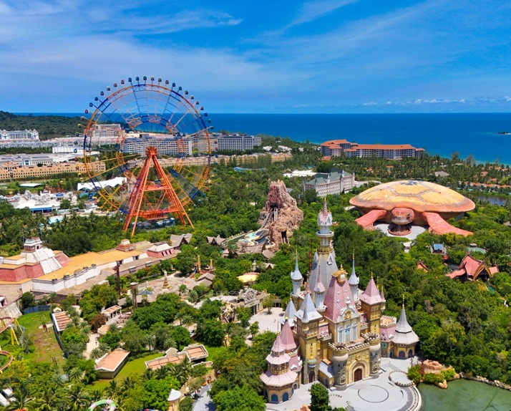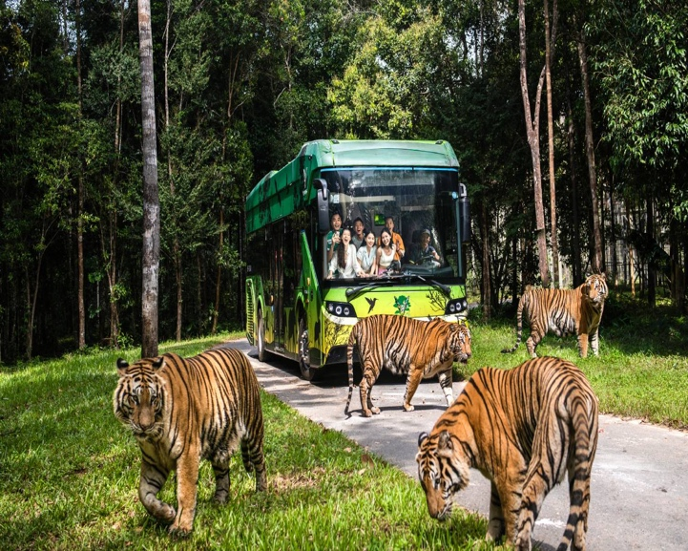
Then we go back to hotel for relaxing!
Overnight in Phu Quoc.

OPTIONAL TOUR 2: Visiting the 6 most popular sites in the South of Phu Quoc
Phu Quoc Prison (Coconut Tree Prison)
Visit this historical site to learn about the heroic and tragic period of Vietnamese history. You'll see models recreating brutal torture scenes and the resilient spirit of revolutionary soldiers.
Note: This is a historical and educational site that can be emotionally impactful.
Pearl Farm
Learn about the unique pearl cultivation process in Phu Quoc. You'll have the opportunity to admire natural and cultured pearls, as well as purchase high-quality pearl jewelry.
Note: Be cautious of overly cheap products to ensure quality.
Sao Beach – one of the most beautiful beaches in Phu Quoc with fine white sand and clear blue water. You're free to swim, take photos, or participate in other beach activities (at your own expense).
Phu Quoc Fish Sauce Factory
Learn about the traditional production process of the famous Phu Quoc fish sauce, an indispensable specialty of the island. You can buy pure fish sauce as a gift.
Phu Quoc Pepper Farm
Visit a pepper farm, learning about how pepper – another distinctive agricultural product of Phu Quoc – is grown and cared for. You can purchase fresh or dried pepper as a souvenir.

DAY 8: PHU QUOC ISLAND – FLIGHT TO HO CHI MINH [MEALS: B]
Having breakfast at hotel.
Then you will be transferred to Phu Quoc International Airport (PQC) for your flight back to Ho Chi Minh.
Overnight in Ho Chi Minh.

DAY 9: HO CHI MINH – DEPARTURE [MEALS: B]
Having breakfast at hotel.
Say goodbye to Vietnam and see you next time !

End of Services

PRICE PER PERSON IN USD
Validity: 01st Oct, 2025 - 31st Dec, 2026
Description | Adults (>12 yr old)
 | 1 | 2 | 3-6 | 7-10 | Single Supplement
 | Single Room | Twin/Double Shared Room
Category 3*
Category 4*
Category 5*

ADDITIONAL COST FOR FLIGHT
Departure | Arrival | PRICE PER PAX | AIRLINES
TAN SON NHAT International Airport  SGN | PHU QUOC International Airport  PQC |  | VNA  Economy Class
Note: Price can be change based on seats available, please reconfirm before booking
Airfares is in economy class and including 7 kg carry-on baggage & 20 kg checked baggage
All airfares can be issued at your end

INCLUSIVE OF ABOVE PROGRAM:
- Accommodation in twin/double room with daily breakfast (check-in and check-out around noontime).
- Services of a driver and private mordern air-conditioned vehicle during all tours and transfers.
- Professional English-speaking guide during day tour.
- Entrance fees for all visits as mentioned in the itinerary.
- Meals (B/L/D) (Breakfast/Lunch/Dinner) as indicated in the program.
- 01 bottles of mineral water per person per day on days of sightseeing.

EXCLUSIVE OF ABOVE PROGRAM:
- Early check-in or late check-out.
- International & Domestic flight tickets (quoted separately)
- Meals (other than mentioned in the program)
- Additional transfer required due to any emergency situation.
- Visa - as per country requirements.
- Offering tips and expressing gratitude for guides and drivers is recommend.
- Travel insurance (we highly recommend that you purchase adequate insurance).
- Optional excursions and activities.

LIST OF HOTELS USE:
*Important Note: All hotels are subject to change to the similar ones
City | 3* Category | 4* category | 5* category
HO CHI MINH | AVANTI HOTEL SAIGON  DELUXE  https://avantihotel.vn/ | THE ODYS BOUTIQUE HOTEL  DELUXE  https://theodyshotel.com/ | REX SAIGON HOTEL  DELUXE https://www.rexhotelsaigon.com/
PHU QUOC | NESTA PHU QUOC HOTEL  SUPERIOR BALCONY  https://nestahotel.com.vn/ | SUNSET BEACH RESORT  DELUXE  https://sunsetbeach.vn/ | SEASHELLs PHU QUOC  CLASSIC CITY VIEW  https://www.seashellshotel.vn/

